**Concept Note Submission**

**Course:** ECO490

**Section:** 01

**Submitted to:**

**Syed Basher**

Professor

Department of Economics

East West University

**Submitted by:**

* Nafew Prodhan

ID: 2019-1-30-033

**Date of Submission:** 23-10-2022

**The role of domestic and foreign political instability to determine the exchange rate of BDT**

**Research Problem**

Traditional exchange rate determination theory believes that the macroeconomic variables such as the economic scale, factor liquidity, money supply, interest rate and inflation level of a country are the basis to determine the exchange rate. Researchers have found that traditional macroeconomic analysis methods cannot completely explain the exchange rate determination and fluctuations in reality, especially the short-term fluctuations. In the 1990s, a group of researchers represented by Frieden pointed out that exchange rate determination is not only an economic, but also a political issue. However, the definition of political pressure and the approaches of describing political pressure are still disputed, more importantly, conclusions reached by these studies are contradictory. For example, in 2018, Japanese Yen (JPY) & Swiss franc appreciates against US dollar on US political uncertainty (Reuters, 2018). In the case of RMB, some authors validated that external political instability increased the fluctuation of RMB in their studies (Chao & Tung, 2013; Wang, 2017), while some researchers showed that US political pressure had no significant impact on RMB (Liu and Pauwels, 2012). So, in different circumstances and for different currencies, impact of political instability on currency can be different. Bangladesh has ranked 161st position at political stable index among 194 countries (the global economy, 2021). From the chart below we can see, the domestic political stability points are always negative for Bangladesh. On the other hand, BDT is depreciating over the time. In 2022, BDT depreciates significantly against USD. Do domestic and external political instabilities have any impact on exchange rate of BDT?

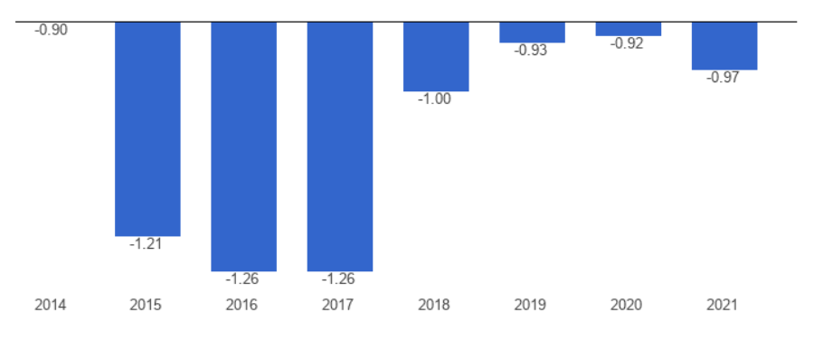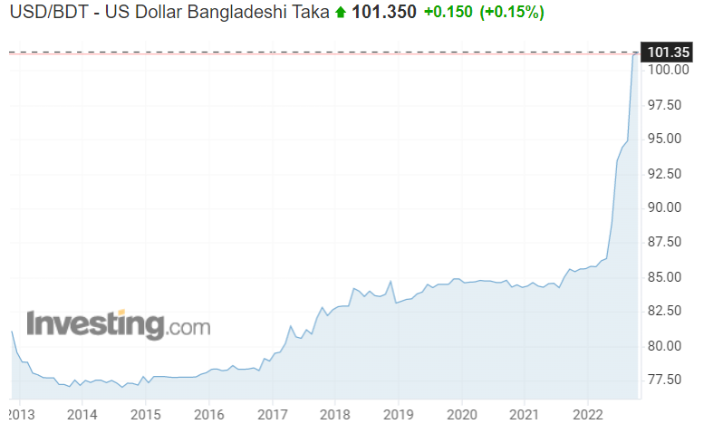

*Figure: Bangladesh - Political stability Figure: USD/BDT*

To understand the relationship between non-economic factor and the exchange rate of BDT, we need further studies in this sector. It is essential to encompass Political uncertainty in the conventional macroeconomic model and estimate its effect in determining macroeconomic variables. Analogously, an exchange rate determination model is not an exception.

**Research question:**

1. How do non-economic variables (Political instability, corruption, turmoil, governance…) contribute to the exchange rate determinants?

**Research objectives:**

The purpose of this study is to examine the impact that domestic and foreign political instability has on the BDT exchange rates volatility. The paper will include all the relevant variables and countries which could have significant impact on the exchange rate of BDT. The paper will extend the monetary model of BDT exchange rate by incorporating domestic and foreign political instability.

**References**

Frieden, J.A., 1994. Exchange rate politics: contemporary lessons from American history. Rev. Int. Polit. Econ. 1 (1), 81–103. <https://www.tandfonline.com/doi/abs/10.1080/09692299408434269>

The global economy, 2021, Bangladesh Political stability, <https://www.theglobaleconomy.com/Bangladesh/wb_political_stability/>

Chao, W.C., Tung, C.Y., 2013. Does China really say no? The impact of international political pressure on China’s exchange rate policy. Issues Stud. 49 (2), 1–34.

Liu, L.G., Pauwels, L.L., 2012. Do external political pressures affect the Renminbi exchange rate?. J. Int. Money Financ. 31 (6), 1800–1818.

Exchange rate USD/BDT, 2022, investing.com